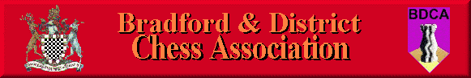

Bradford DCA Committee Meeting Minutes
Meeting held 6th July 2017 at the Central Division Club, Clayton Lane
Present: Andrew Bak, Adrian Arthur, Keith Marsh
1. Previous month’s meeting minutes & Matters Arising
N/A.
2. Secretary’s Report
No further certainty on which teams are entering the league this season so it will be difficult to confirm the details of the league structure.
We will consider delaying the start of the Hepolite competition to allow more time for teams to enter. Perhaps bring the Individuals or Clough forward.
3. Competition controller’s Report
The Bob Burns was ongoing smoothly.
4. Website Editor’s Report
KM has recently moved house so should be able to provide more regular updates to the website going forward.
5. Treasurer’s Report
College’s league fees are still outstanding.
6. Bradford Congress
Entry form to be published on the website. Has been sent out to events through Chess Direct. To invite Stuart Swire to the next meeting.
7. AOB
Following the AGM, discussion was had about hosting an event on a Saturday in the near future as an Open event to allow people to come down and play.
KM to investigate kick-starting the BDCA Facebook page to complement the active Facebook group.
AA going to investigate possible link-ups with Bradford PA or Bradford Bulls, although it may be difficult at this time with Bradford Bulls in particular.
Meeting Closed
Next meeting to be held in August

