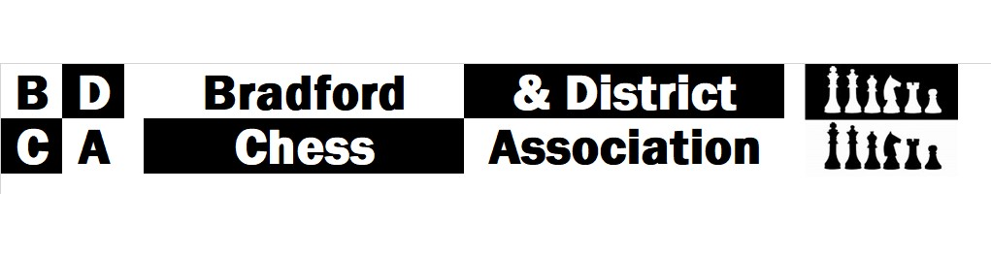
Minutes of the BDCA AGM 2022

Tuesday 17th May 2022, Owlet Hall Social Club
18 Present: Robert Dennington, Adrian Arthur, David Barlow, Andy Walker, Ian Jewsbury, Les Johnson, Dave College, Dennis Palframan, Dave Sykes, Keith Marsh, Phil Watson, Mark Crowther, Andy Wainwright, Mike Bramson, John Holiday, Michael Overend, Fazal Rabbi, Lee Crawford

- Apologies for absence

Julian Toothill, Ihor Lewyk, Wil Quick, Matt Webb, David Adam, Richard Bowman, Andy Bak, Karim Khan

- Minutes from the AGM 2021
No matters arising

- Chair’s Report

Adi reported that the new league structure was not a complete success. The number of players and teams had reduced and two clubs failed to complete their fixtures. However, we had returned to playing chess and there were 2 new clubs, the Chess Centre and Saltaire.

Adi thanked the out-going officers, Wil and Andy Bak. He congratulated Andy on being awarded the Carey trophy for his years of service.

- Treasurer’s Report

- Accounts were presented by David Barlow – see attached. Andy Walker to audit accounts.

- 3 accounts are now consolidated in to one account to avoid multiple charges.

- £2000 of the balance is ‘ring-fenced’ from Sam Scurfield’s donation. DB said although Sam or his estate had not asked that money be spent in a particular way, the committee thought it was appropriate to spend the money on the development of junior chess.

Andy Wainwright expressed a concern that the money could be seen as only being spent on projects initiated by the Chess Centre. David invited all clubs to think about how the money could be spent in the near future.

- In 2020-21, £500 (£600 in total) was provided for chess equipment in primary schools in north Bradford and Ilkley areas, organised by the Chess Centre.

- We now have charges of £5 per month. DB said the committee has decided to consider moving from HSBC to one which does not charge a fee.

- As the individual competition fees were not paid out in prize money in the 2019-20 season, DB suggested entrants in 2019-20 should have free entry in 2022-23.

- DB noted that the income from club fees has reduced from about £700-800 pre-Covid to £500.

- League Organiser’s Report
RD reported on the winners of the 6 Board and 4 Board Leagues.
6-Board Ilkley
4-Board Play Off South Bradford A
4-Board League A Chess Centre Assassins
4-Board League B South Bradford B

- Competition Controller’s Report,
In the absence of Andy Bak, David Barlow reported the winners:
Boyd | Saltaire
Clough | YSS Gambits
Hepolite Shield | Bingley
Hepolite Plate | Chess Centre Bandits
Hepolite Dowry | Ilkley
Hepolite Cup | South Bradford A
Webster Trophy | E Gorrell
John Smith | F Rabbi
Cocking | G Farrar
Totty Cup | D Barlow
Fattorini | D Barlow
Carey Cup | A Bak

DB apologised for being unable present trophies at this meeting as the engraver has injured his wrist!

- Election of Officers

 | Officers 2021-22 | Officers 2022-23
President | Matthew Webb | Re-elected unanimously
Chairman | Adrian Arthur | Re-elected unanimously
Vice Chairman | John Holiday | Re-elected unanimously
Association secretary | Wil Quick standing down | Vacant
League Controller | Robert Dennington | Re-elected unanimously
Treasurer | David Barlow | Re-elected unanimously
Competition Controller | Andy Bak standing down | Robert Dennington elected to run Clough & Hepolite for 2022-23.  David Barlow offered to run the individual competitions for 2022-23.
Rating Officer | Lee Crawford | Re-elected unanimously
Web Master | Lee Crawford | Re-elected unanimously
Press Officer | Vacant | John Holiday elected unanimously
Trophy Secretary | Vacant but engraving will continue to be undertaken by David Barlow | David Barlow to continue to organise engraving for 2022-23.

- Proposed Rule Changes
The following rules were agreed and replace existing rules:
Rule 3, proposed by R Dennington
Players will be registered with a club, but in order to reduce defaults, may play for multiple clubs in the season.

Rule 17, proposed by R Dennington
Each division of the League shall consist of no more than ten teams. All teams shall consist of four boards. A club shall have a maximum of three teams in any division.

Although there were some reservations mainly expressed by Saltaire, the meeting felt that 4 boards would reduce defaults and encourage clubs to enter more teams.

Rule 40 (Webster Trophy) proposed by D Barlow
To be awarded to the player with the highest aggregate score across all competitions who is under 18 on 1st September in the year the season starts.

Rule 46 (Hepolite) proposed by J Holiday
Each player has 20 minutes plus 10 seconds per move to complete each game.
Rule 9
Before a match starts the captains shall write their players in order of grades according to the latest official monthly rating list. No player should play on a higher board than a player with a grade that is greater by 150 or more points.

Rule 29 (individual competitions) proposed by Wil Quick
The individual competitions are: a) The Barnett Trophy - Open to all registered members, b) The Parkinson Trophy - Open to all registered members (Under 1,900), c) The Hutchinson Trophy - Open to all registered members (Under 1,700), d) The Bak Trophy - Open to all registered members (Under 1,500).

However, the meeting noted that Rule 30 states that:
The Competition Controller is in charge of these competitions and their decision on any of these points shall be final.
Rules 56 (Clough) proposed by Wil Quick
Byes requested by a team score 2.5 points. Such a Bye must be requested before the draw for that round is made. No requested Byes allowed in the final round of matches. No team allowed more than one Bye throughout the competition. Table for 4-board teams based on the latest official monthly rating list as outlined in Rule 8. 4

Grade difference between teams | Handicap points (Ha) weaker team | Handicap points (Ha) stronger team
0-250 | +1.5 | +1.5
251 – 800 | +2 | +1
800 – 1,400 | +2.5 | +0.5
1,400 or greater | +3 | +0

Rule 58 (Clough) proposed by Wil Quick
In order to calculate the opposing team's Handicap points, absent players are graded as follows: If a nominated player, expected to play, fails to arrive in time, that player's grade is given to his prescribed board which will be in the correct board order according to that grade. If a team has fewer than 4 players to start with, the available players must fill the highest available boards (i.e., the lowest board(s) are defaulted and each defaulted board is given 1,500 rating points).

Rule 61 (Clough) proposed by Wil Quick
Players with no previous grade are given a provisional grade of 1,500. The grade to be used for ungraded players under the age of 16 at 1st September in the year of the start of the competition will be 1,150.
Rule 62 (Clough) proposed by Wil Quick
Players whose grades have expired should use their most recent published grade, minus 60 rating points for each year that it is out of date, up to a maximum 300 points deducted.
Rule 63 (Clough) proposed by Wil Quick
Any player graded below 750 based on fewer than 10 games should be given an adjusted grade of 750.
Rule 65 (Clough) proposed by Wil Quick
No team may have an aggregate grade of greater than 7,200. There is no restriction on individual grades.
Rule 15 Typo to be corrected to
For all League and Clough matches

A proposal by RD to change Rule 27 to ‘3 points for a win and 2 for a draw…’ was rejected.

- AOB

- Andy Wainwright said we need to address the issue of a league with declining numbers. He asked clubs to address issues of noisy and cold venues which does not give a good impression to new players.

- Adi reported that Q Gardens have purchased a trophy to be awarded as a grading prize in the Burns competition to commemorate Tony Lightowler.

- RD said he would send out entry forms to clubs for the league, Clough and Hepolite competitions shortly.

- Keith Marsh stressed the need for all clubs to enter as many 4 board teams as possible.

