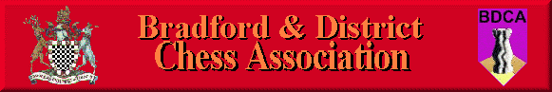

Bradford DCA Committee Meeting Minutes
Meeting held 2nd March 2017 at the Central Division Club, Clayton Lane
Present: Wil Lilburn-Quick, Andrew Bak, Adrian Arthur, Dave Barlow
Apologies: Sam Scurfield, Karim Khan, Keith Marsh
1. Previous month’s meeting minutes & Matters Arising
No progress had been made with adjusting the Bradford Congress form, This is to be reviewed
2. Secretary’s Report
The Hepolite is continuing to be plagued with many defaulted matches and matches played over five boards. Daniel Dufton has recently made a post in the Facebook group calling for a discussion about amending the Hepolite format where the following ideas have been floated:
- Reducing the Hepolite to 5 boards
- Making it a Rapidplay competition
- Handicap KO
- Removing the Hepolite and either shorten the calendar or extend the league system
Undercliffe C are due to receive a league point deduction for their second breach of rule 9a.
3. Competition controller’s Report
The latest rounds of the individuals have not been graded on Chessnuts yet.
4. Treasurer’s Report
Bills have been sent out to the clubs for this season’s fees.
No bill has been received from the ECF for the Congress game fees. This process has been delayed due to the recent death of the ECF’s John Philpott.
5. Hepolite Draws
The draws were carried out.
6. ECF Membership Changes
AB noted that the ECF were considering making amendments to the ECF Game Fee structure – this was to be voted on at the Finance Council in April.
7. AOB
Simon Deighton of Leeds City Centre Chess Club sadly passed away recently. Although he did not play chess in the Bradford league, many players in the Bradford league knew him well and he will be sadly missed.
Meeting Closed
Next meeting scheduled for Thursday 6th April 2017 at 8.00pm, Central Division

